Software Requirements Specification
for
College Event Management App

Prepared by:

Jobin Don Benny
Abin S Varghese
Francis Sunny
Bibin Mathew

Published On:19/05/2022
Table of Contents
Table of Contents ii
Revision History ii
1. Introduction 1
1.1 Purpose 1
1.2 Intended Audience and Reading Suggestions 1
1.3 Product Scope 1
1.4 References 1
2. Overall Description 2
2.1 Product Perspective 2
2.2 Functional Requirements 2
3. Other Nonfunctional Requirements 4
3.1 Performance Requirements 4
3.2 Safety Requirements 5
3.3 Security Requirements 5
3.4 Software Quality Attributes 5

Revision History
Name | Date | Reason For Changes | Version

introduction

Purpose
A platform where various events coordinated by the college and professional societies can be hosted and accessed by the students. The main purpose of this platform is to expose students to various non-academic initiatives that help in the development of their professional interests. Many events conducted by the college or the professional societies sometimes go unnoticed because of a lack of a platform where all these events are listed and properly organized. This app tries to solve this issue by creating a platform where a detailed description of all the upcoming college events is posted.

Intended Audience and Reading Suggestions
This app is a prototype for handling various college events and it is restricted within the college premises. The intended audience is college students who are interested in participating in various technical/non-technical events.

Product Scope
The purpose of this application is to create a convenient and easy to access platform for students to enroll and engage themselves in events held and organized by the college. The scope can be further extended to enable students to learn new technologies or acquire volunteering skills as well.

References
https://krazytech.com/projects/sample-software-requirements-specificationsrs-report-airline-database
https://myhistoryfeed.medium.com/complete-software-requirements-specification-srs-example-5bd08f107206

Overall Description

Product Perspective
This application provides the following components:

- EVENT DESCRIPTION
It includes a summary of events along with details regarding the number of seats available, The start/end dates of the event, The details of the host and contact details of the volunteer in charge, etc.

- STUDENT DETAILS
It includes the “My Profile” feature that shows the student ID, name, address, phone number, department, etc. Students can choose whether to make their profile details public for /her peers.

- REGISTRATION DESCRIPTION
Provides a unique registration ID for each registered student and a receipt for the registered event.

- ADMIN PRIVILEGES
Admin has all the superuser privileges and can add or remove users from the platform. Admin also has full control over the authority of volunteers.

Functional Requirements
Three modules are identified in this project

1: ADMIN MODULE

The attributes of this module are AdminID, AdminName, and Password. Admin

- Use case: addUser () and removeUser ()
This feature enables the admin to add students as well as volunteers to the platform and assign them a unique ID and password (volunteers cannot reset their password). Also, as a volunteer at an event, that person has the authority to add/remove users to his/her respective event.

- Use case: addEvent () and deleteEvent () and update Events ()
By default, events can be added, deleted, or updated by the admin only. But if the admin assigns a volunteer for this task, he/she can also perform the task of adding, deleting, and updating as well.

- Use case: checkParticipants ()
The list of all the participants can be accessed only by the admin by default.

- Use case: checkPayments ()
The details of payment (if any available) can be only accessed by the admin by default.

- Use case: Login ()
Admin can log into the app using his/her credentials which requires a two-factor authentication procedure.

2: USER MODULE

The attributes of this module are user ID, user name, and password. This module consists of students who have registered in the app using their credentials.

- Use case: registerToEvent ()
This function is what distinguishes a normal user from a participant. Once the user registers for an event he/she will be considered a participant from that point onwards.

- Use case: login ()
The user can log in to his/her account using the credentials created during the initial registration. (Two Factor Authentication is optional)

- Use case: signUp ()
The initial step in becoming a user is to sign up using his/her credentials. Before signing up he/she has limited access to the app. All the events are visible to non-users but registration to an event is only possible once you have signed up and logged in.

- Use case: payment ()
Users can pay for the events they wish to participate in and complete the registration process from within the app.

- Use case: viewEvent ()
Users can view the details of all the listed events in the app.

- Use case: editProfile ()
Users have the option to edit their profile and make changes to account/personal details. This authority Is limited as some data fields such as email and phone number are necessary for the working of the app and cannot be left blank.

- Use case: resetPassword ()
Users have the option to change their passwords if deemed necessary or in case they forget /her password.

3: VOLUNTEER MODULE
The attributes of this module are volunteer ID, Username, and password.
This is a privileged set of users who can perform elevated functions compared to normal users.
- Use case: login ()
Volunteers can log in to/her account using the credentials provided by the admin.

- Use case: checkParticipants ()
The details of the participants can be viewed by volunteers.

- Use case: addParticipant () and removeParticipant ()
They can add or remove participants to the event they are volunteering for.

- Use case: checkPaymentStatus ()
If payment is part of the event volunteers can also access details of participants who have completed the payment.

The major modules are shown in the image below.

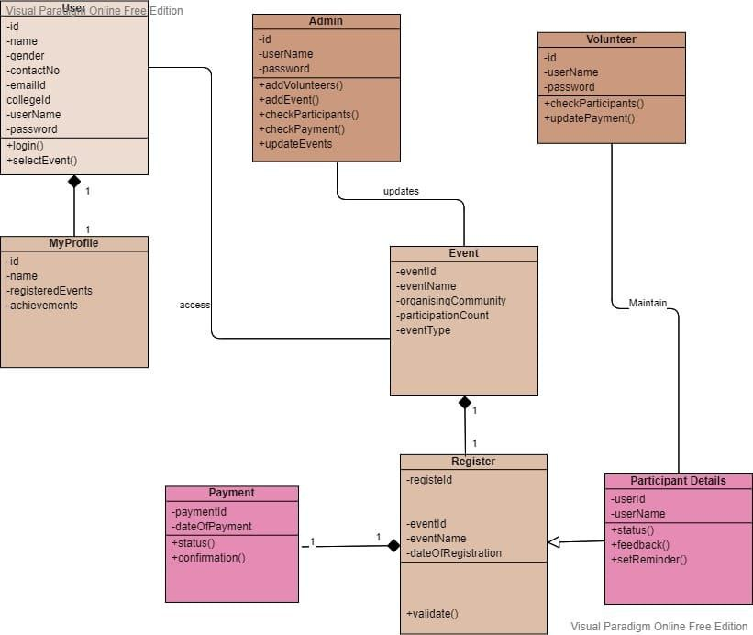

Nonfunctional Requirements

Performance Requirements
The basic objective is to reduce the redundancy of the stored data. Storing information several times leads to wastage of storage space and an increase in the total size of data stored.

Safety Requirements
The app provides recovery methods in case any data is lost. The recovery method restores a past copy of the database that was backed up to archival storage and reconstructs the database to its previous state.

Security Requirements
Every password is encrypted uniquely so that in case of a data breach password would not be the compromising factor. Only the admin has the authorization to access all the event participatory details. The registration procedure is also encrypted to further improve the security experience.

Software Quality Attributes
AVAILABILITY:
The app should be up and running

CORRECTNESS:
Event details displayed, Data stored in the database, and Data collected should be correctly and accurately stored in the database and is needed to be retrieved as the same.

MAINTAINABILITY:
The admins and volunteers are responsible to maintain the correctness of the events displayed in the app.
USABILITY:
The app should be able to handle and satisfy as many numbers of students as possible.

